1. Go to SE11
2. Select Data Type. Enter the name of table type as zxxxxinttab1 where XXXX is your empcode.

104329 in this example.

1. Select Table Type.
2. Select Line Type. Enter Z104329EMP. This is a DB table created in DDIC.
3. Save and Activate.

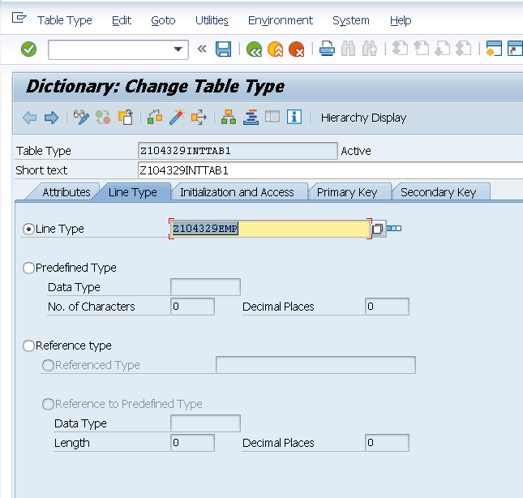

REPORT z.  
  
data itab1 TYPE Z104329INTTAB1. *"TABLE TYPE*  
data WA TYPE Z104329EMP.  
  
SELECT \* FROM Z104329EMP  
  INTO TABLE itab1.  
    
 LOOP AT itab1 INTO WA.  
 WRITE:/ WA-EMPNO , WA-ENAME.    
     
 ENDLOOP.  
     wa = 40. APPEND wa to itab1.  
wa = 50. APPEND wa to itab1.  
ENDFORM.  
  
FORM dispinttab1.  
  LOOP at itab1 into wa.  
    WRITE : / sy-tabix, wa.  
ENDLOOP.  
ENDFORM.